Digital Communication (ETEC-303), V Sem.

Assignment 2, Unit-III/IV

Aug-Dec’21

Q 1. Explain the significance of eye pattern. Give its two applications also.

Q 2. Derive an expression for the transfer function of the Matched Filter Receiver.

Q 3. Prove that for a matched filter, the maximum signal component occurs at t=T, (i.e. sampling instant) and has magnitude= E, i.e. energy of the signal x(t).

Q 4. How a correlation receiver and matched filter receiver are similar in their areas of operations? Use suitable block diagram to explain.

Q 5 a). Given are the signals.

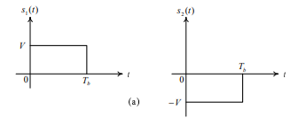

Find the basis function. Also, draw its constellation diagram.

or

Q 5b). Explain maximum likelihood receiver structure.

Q 6. Explain QPSK Modulator and Demodulator with required block diagram. Also draw the constellation diagrams and probability of error.

Q 7. Draw the ASK, FSK and PSK waveforms for 011011.

Q 8. Compare MSK with QPSK. Also Explain MSK modulation and demodulation.

Q 9. Derive the probability of error for Binary ASK and Binary PSK systems and compare them.

Q 10 a). Prove that the reconstruction of DPSK Signal by the discussed technique is independent of choice of extra initial bit.

Given the binary bit as 0010010011.

or

Q 10 b). Explain DEPSK Receiver. Also show with an example that how error always occur in pairs in it.